Build and modernize AI Apps on Azure
95 Hr 5 Min Remaining
Instructions Resources Help 100%

Lab 08: Recognizing and translating speech to text using speech translation service
Introduction: Speech translation service enables real-time, multi-language speech-to-speech and speech to text translation of audio streams.
Lab Type : Instructor Led
Estimated Duration :15 min
Objective:
In this lab, you run an application to translate speech from one language to text in another language.
more...

Exercise 1: Creating a new Azure Cognitive Services resource using Azure Portal

Task 1: Create Azure Cognitive Speech service resource
- Open a tab in a browser and go to the Speech Services https://portal.azure.com/#create/Microsoft.CognitiveServicesSpeechServices and sign in with your Azure credentials if prompted..
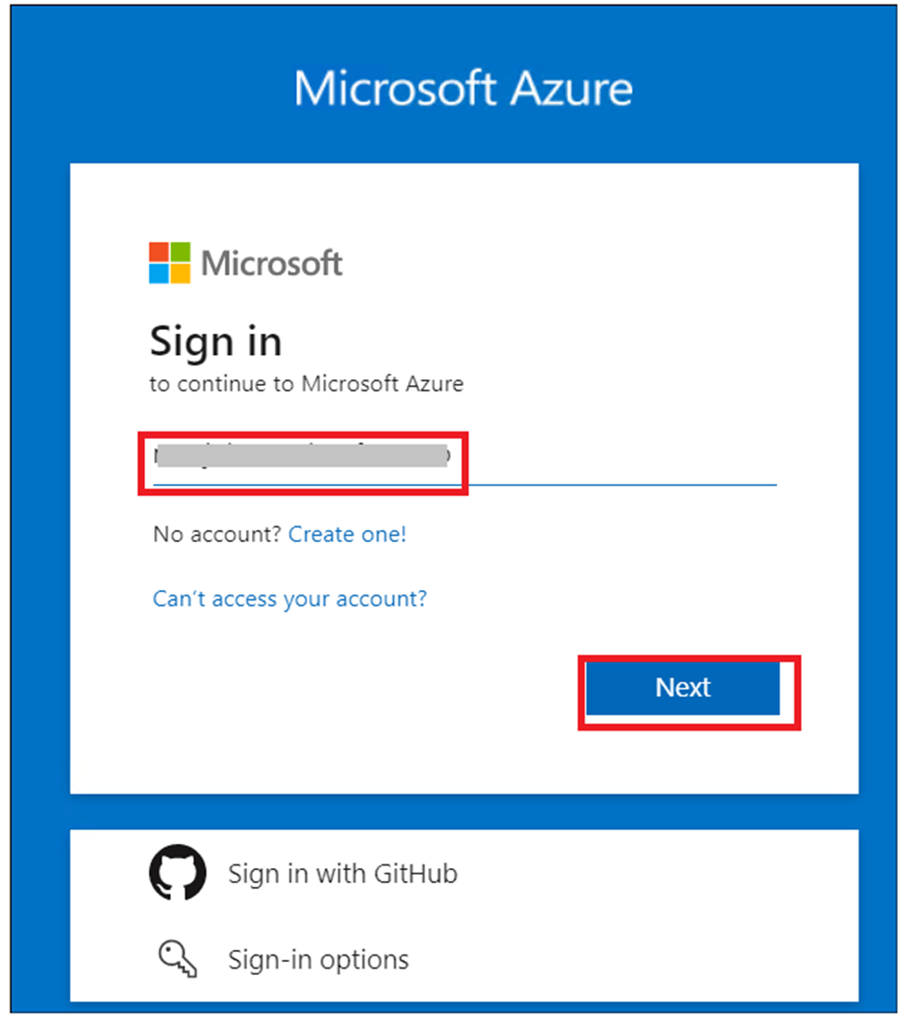
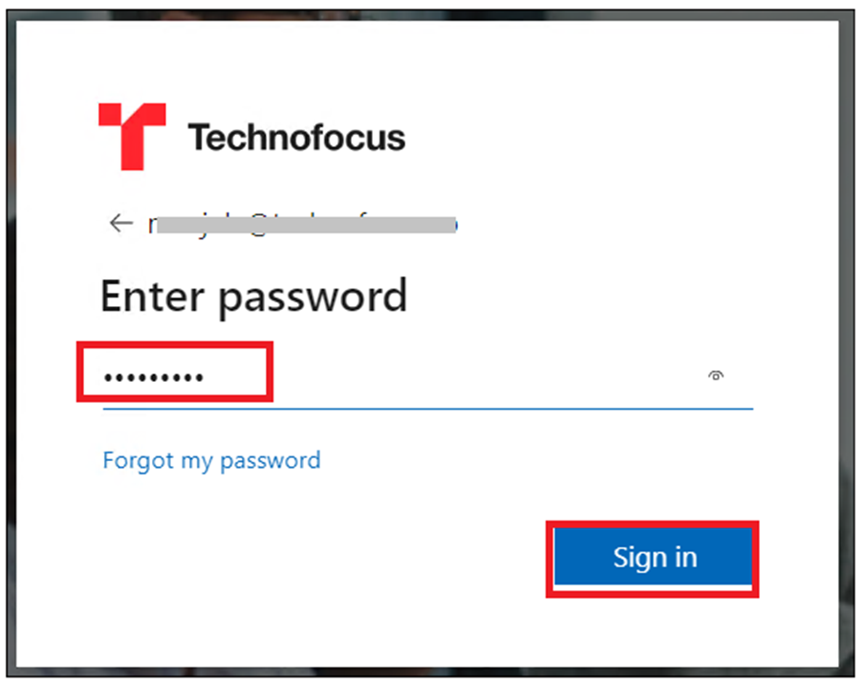
- On the Create page, provide the following information and click on Review + create.
Project details | Description
Subscription | Select your subscription ( This will be selected by default).
Resource group | Create New -> azcogntv-rg1 Click on OK.
Region | East US
Name | CognitiveSpeechServicesResource
Pricing tier | Free F0
- 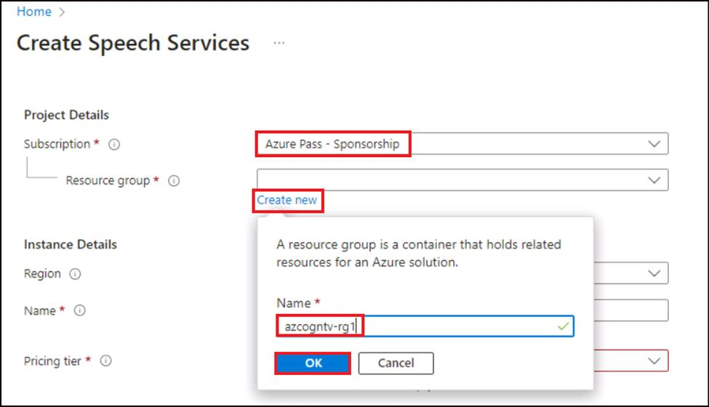
- 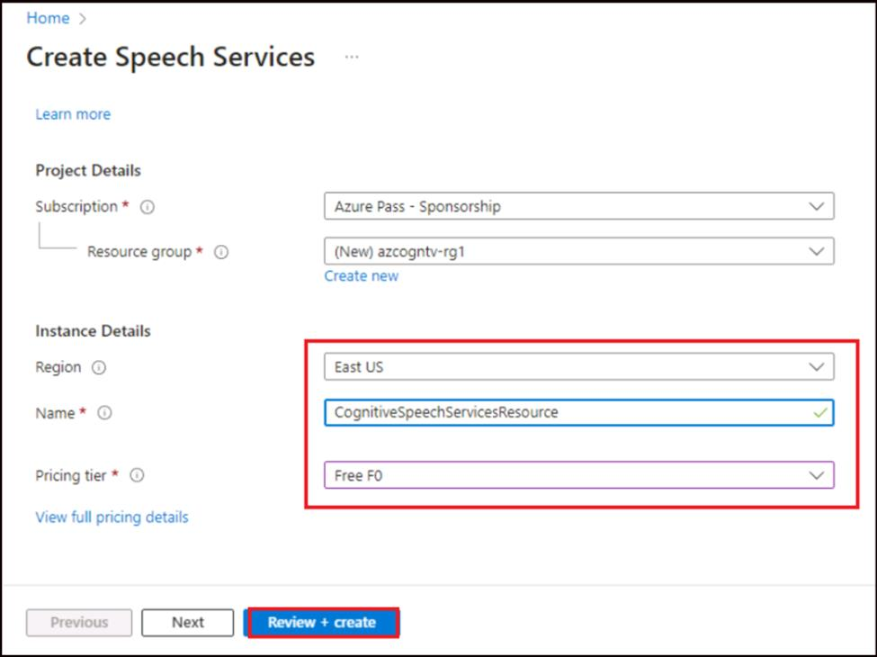
- Once the validation is passed, click on Create button.
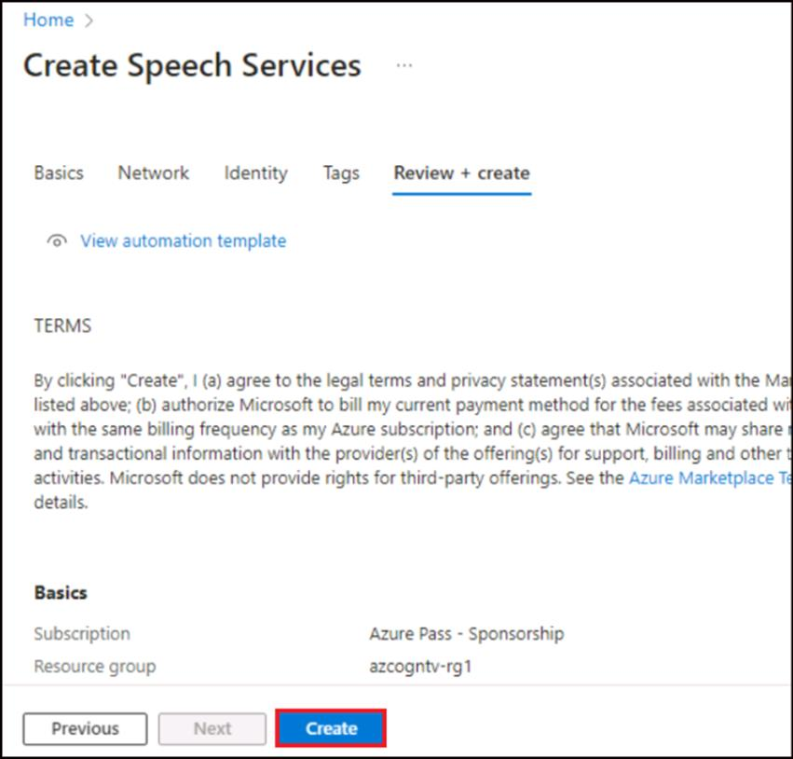
- Wait for the deployment to complete and then click on Go to resource.
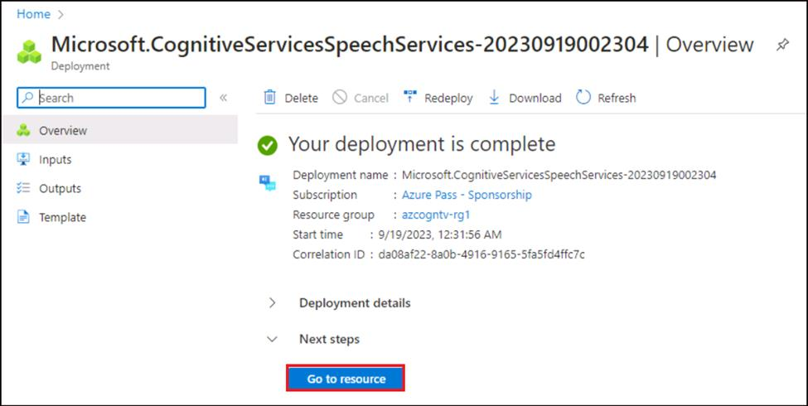
- Click on Keys and Endpoint from left navigation menu and then copy and save Key 1 and Endpoint values in a note pad. You will be using these values in further labs.
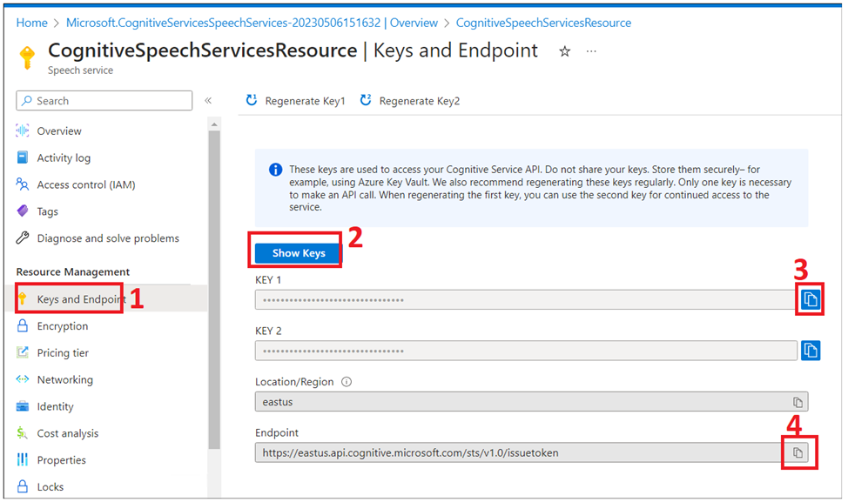

Task 2: Create Azure Cognitive Language service resource
- Open a new browser and go to the https://portal.azure.com/#create/Microsoft.CognitiveServicesTextAnalytics and sign in with your Azure Slice credentails.
- Without selecting any option on the page, click on Continue to create your resource button.
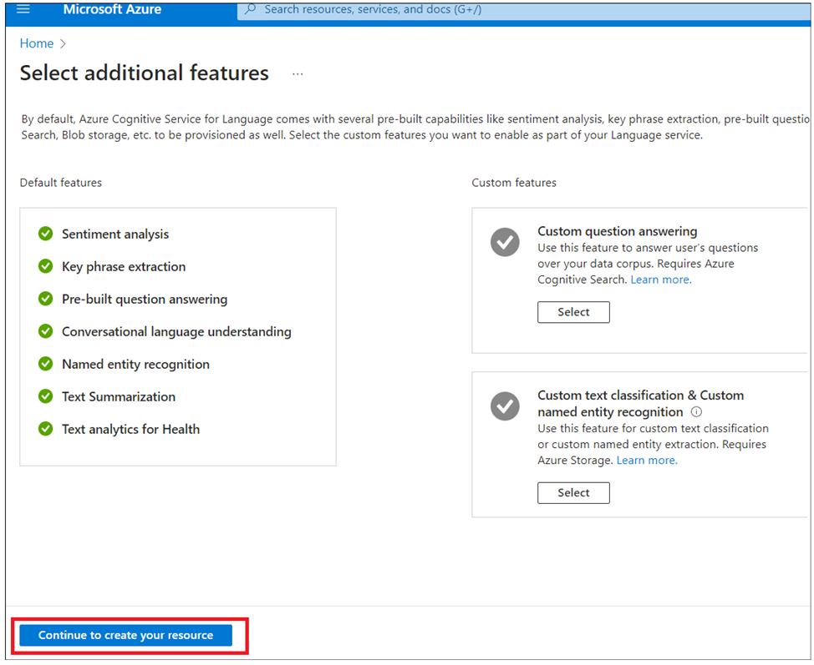
- Update with below details and then click on Review+Create.
  - Subscription :Your Azure subscription
  - Resource Group: Select azcogntv-rg1
  - Region -East us
  - Name: CognitivelanguageResourceXX(Replace XX with any random number)
  - Price tier: Free(F0)
  - Select checkbox:By checking this box I certify that I have reviewed and acknowledge the terms in the Responsible AI Notice.
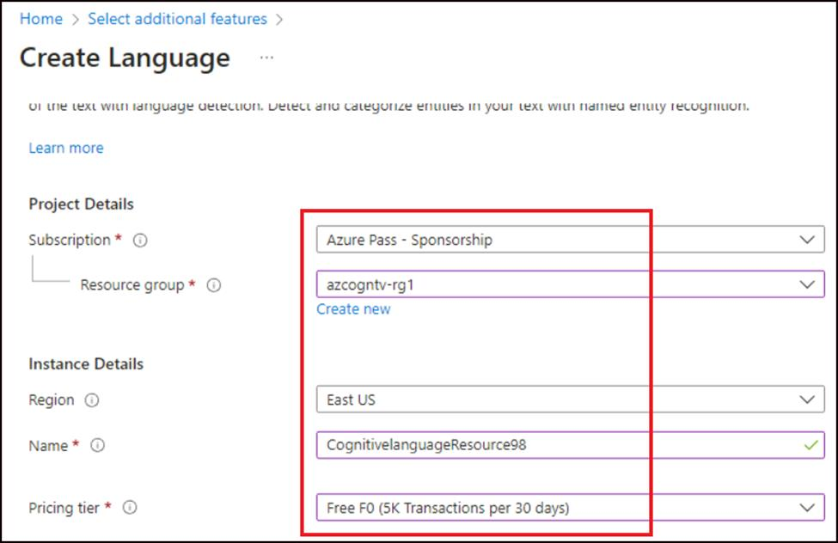
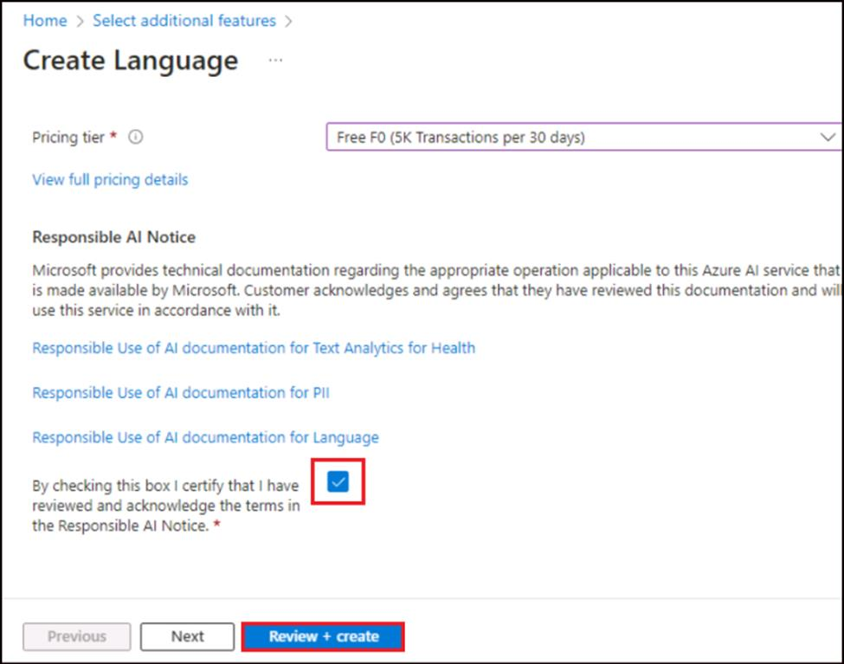
- Review the resource details and then click on Create.
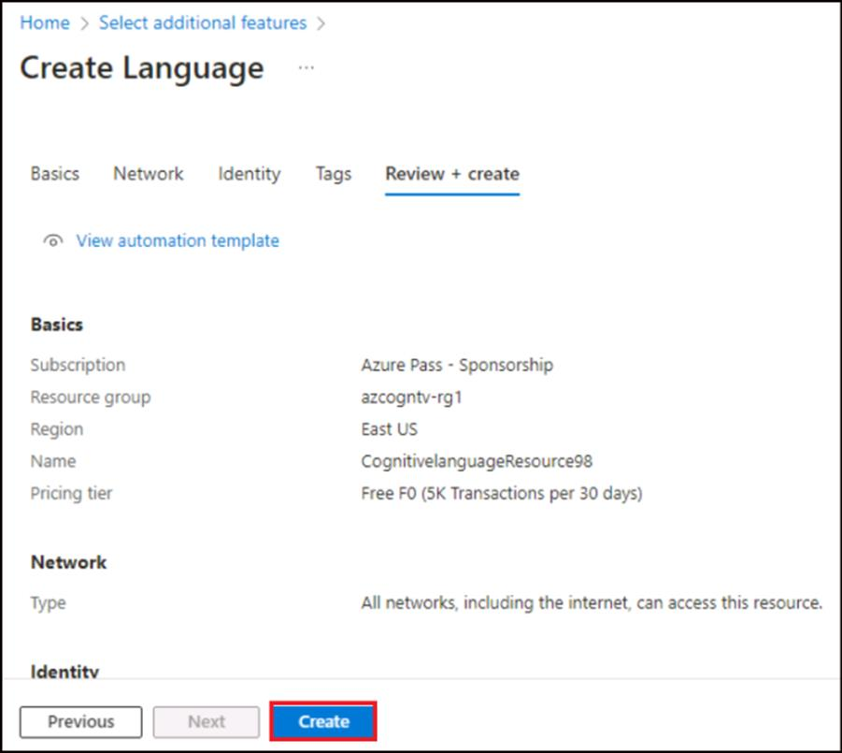
- Wait for the deployment to complete and once the deployment successful, click on Go to resource group
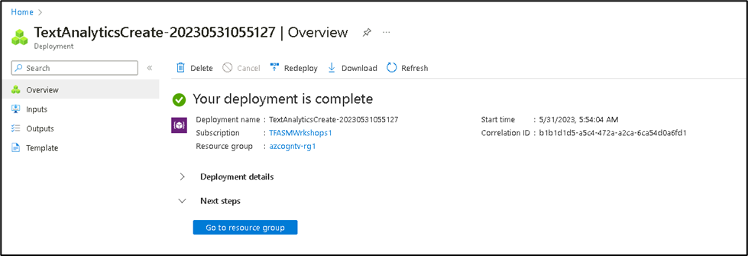
- Click on CognitiveLanguageResource.
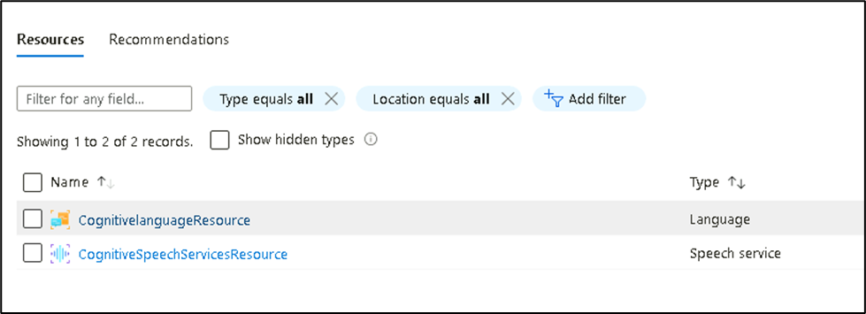
- Click on Keys and Endpoints >Show keys and then take a copy of Key 1 and end point values and save them in Notepad to use them in further labs.
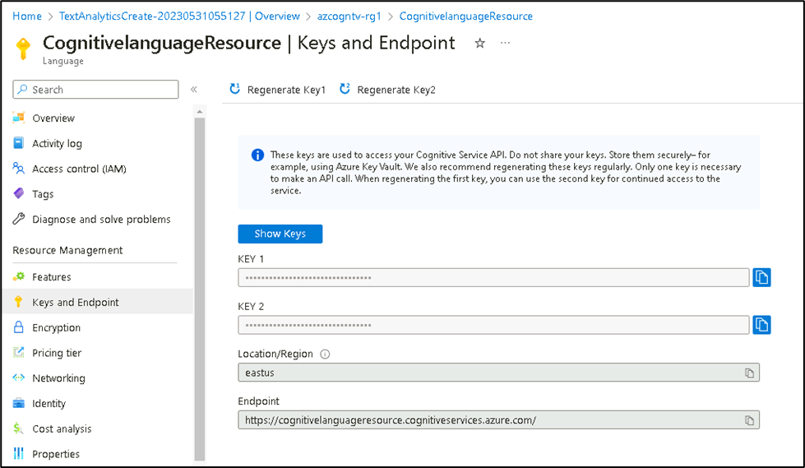

Exercise 2: Recognizing and translating speech to text

Task 1: Set environment variables
Your application must be authenticated to access Cognitive Services resources. For production, use a secure way of storing and accessing your credentials. For example, after you get a key for your Speech resource, write it to a new environment variable on the local machine running the application.
- Open command prompt and run mkdir lab08-Speech-to-Text to create a directory and then run cd lab08-Speech-to-Text
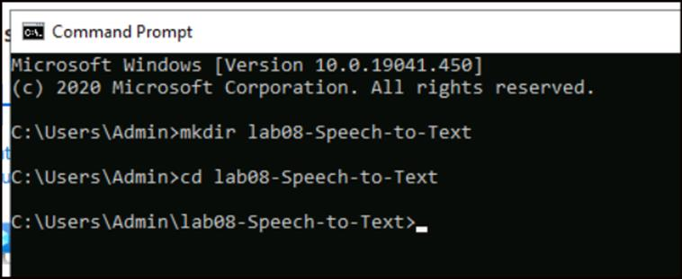
- To set the SPEECH_KEY environment variable, replace your-key with one of the keys for your resource saved in Exercise 1.
- 3. Run below commands, replacing your key with your Speech key values
setx SPEECH_KEY your-key
setx SPEECH_REGION eastus
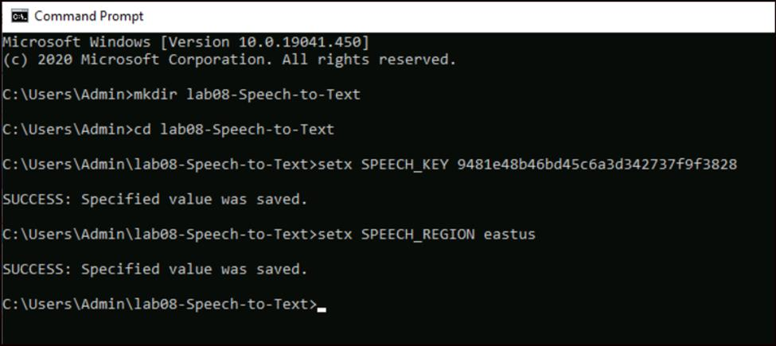
- After you add the environment variables, you may need to restart any running programs that will need to read the environment variable, including the console window.
- Close the command prompt and open it again

Task 2: Translate speech from a microphone
Follow these steps to create a new console application and install the Speech SDK.
- Open a command prompt, go to your directory - cd lab08-Speech-to-Text, and create a console application with the .NET CLI. The Program.cs file should be created in the project directory.
dotnet new console
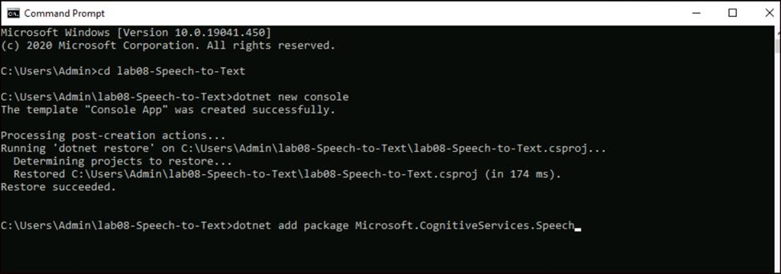
- Install the Speech SDK in your new project with the .NET CLI.
dotnet add package Microsoft.CognitiveServices.Speech
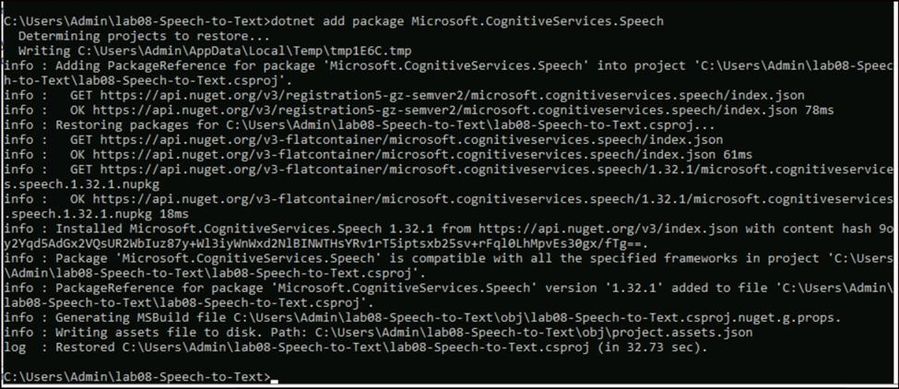
- Open the program.cs file in notepad from C:\Users\Admin\lab08-Speech-to-Text. Replace the contents of Program.cs with the following code.
Note - Make sure you are opening the program.cs file pertaining to the correct lab that you are executing
using System;
using System.IO;
using System.Threading.Tasks;
using Microsoft.CognitiveServices.Speech;
using Microsoft.CognitiveServices.Speech.Audio;
using Microsoft.CognitiveServices.Speech.Translation;

class Program
{
// This example requires environment variables named "SPEECH_KEY" and "SPEECH_REGION"
static string speechKey = Environment.GetEnvironmentVariable("SPEECH_KEY");
static string speechRegion = Environment.GetEnvironmentVariable("SPEECH_REGION");
static void OutputSpeechRecognitionResult(TranslationRecognitionResult translationRecognitionResult)
{
switch (translationRecognitionResult.Reason)
{
case ResultReason.TranslatedSpeech:
Console.WriteLine($"RECOGNIZED: Text={translationRecognitionResult.Text}");
foreach (var element in translationRecognitionResult.Translations)
{
Console.WriteLine($"TRANSLATED into '{element.Key}': {element.Value}");
}
break;
case ResultReason.NoMatch:
Console.WriteLine($"NOMATCH: Speech could not be recognized.");
break;
case ResultReason.Canceled:
var cancellation = CancellationDetails.FromResult(translationRecognitionResult);
Console.WriteLine($"CANCELED: Reason={cancellation.Reason}");

if (cancellation.Reason == CancellationReason.Error)
{
Console.WriteLine($"CANCELED: ErrorCode={cancellation.ErrorCode}");
Console.WriteLine($"CANCELED: ErrorDetails={cancellation.ErrorDetails}");
Console.WriteLine($"CANCELED: Did you set the speech resource key and region values?");
}
break;
}
}

async static Task Main(string[] args)
{
var speechTranslationConfig = SpeechTranslationConfig.FromSubscription(speechKey, speechRegion);
speechTranslationConfig.SpeechRecognitionLanguage = "en-US";
speechTranslationConfig.AddTargetLanguage("it");

using var audioConfig = AudioConfig.FromDefaultMicrophoneInput();
using var translationRecognizer = new TranslationRecognizer(speechTranslationConfig, audioConfig);

Console.WriteLine("Speak into your microphone.");
var translationRecognitionResult = await translationRecognizer.RecognizeOnceAsync();
OutputSpeechRecognitionResult(translationRecognitionResult);
}
}
- Run your new console application to start speech recognition from a microphone:
dotnet run
- Speak into your microphone when prompted. What you speak should be output as translated text in the target language:
Speak this : The Speech service provides speech to text and text to speech capabilities with an Azure Speech resource and then press Enter.
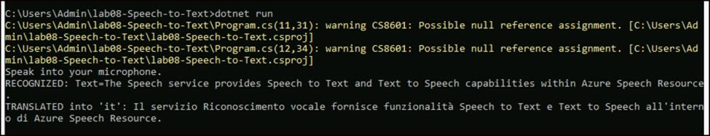
Summary:
In this Lab, you translated speech from a microphone to different language by updating the code of program.cs file.

